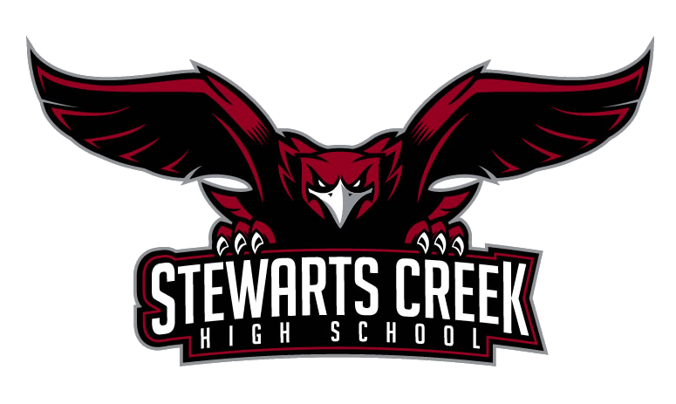ADVERTISING
SIZE PRICES
Eighth Page- Business Card Size- Landscape $50
Quarter Page- 5.5 h X 4.25 w- Portrait $75
Half Page- 5.5 h X 8.5 w- Landscape $150
Full Page- 11 h X 8.5 w- Portrait $300
Inside Covers (1) Check Availability $500
Back Cover- Check Availability $750
All ads and money must be turned in by August 3RD ****
SCHS cheerleaders will provide an ad in the 2021 Football Program to be sold at all home football games. Senior photos are also welcomed.
Artwork must be submitted in EPS, PDF, JPG, or JPEG format
We recommend 300 DPI or higher resolution vector images
Email Ads to SMITHAL@RCSCHOOLS.NET
NO PERSONAL CHECKS ACCEPTED. ONLY CASH, MONEY ORDER OR CASHIERS CHECK!!
NAME/BUSINESS_______________________________________________________________________
CONTACT #/EMAIL_____________________________________________________________________
CHEERLEADER RESPONSIBLE FOR THIS AD___________________________________________________

